An Improved Fire Detection Algorithm Based on YOLOV9

ABSTRACT
An improved fire detection algorithm based on YOLOv9 is presented to enable accurate and real-time identification of fire and smoke in surveillance video streams. The system continuously monitors live camera feeds and detects fire-related events using a deep learning–based YOLOv9 model, generating confidence scores to assess detection reliability. To reduce false alarms caused by environmental disturbances such as dust or lighting variations, temporal validation across consecutive frames is performed before confirming an incident. Upon validation, the detected fire is classified into low, medium, or high severity levels based on confidence scores, allowing prioritized emergency response. Once a fire incident is confirmed, the system automatically triggers an emergency alarm to ensure rapid intervention. Additionally, all detection events, severity levels, and alert details are recorded in structured logs for future analysis, safety audits, and system performance enhancement, making the proposed approach effective for intelligent fire monitoring and early warning applications.
Keywords: Fire Detection, YOLOv9, Smoke Detection, Real-Time Monitoring, Deep Learning, False Alarm Reduction, Severity Classification and Emergency Alert System.

OBJECTIVE OF PROJECT:
The primary objective of this project is to design and implement an improved fire detection system based on the YOLOv9 deep learning model that can accurately and efficiently detect fire and smoke in real time from live video streams. The system aims to minimize false alarms through temporal validation across consecutive frames, assess the severity of fire incidents by classifying them into low, medium, and high levels, and automatically trigger emergency alerts for rapid response. Additionally, the project seeks to maintain detailed event logs to support safety analysis, system evaluation, and continuous improvement, thereby enhancing overall reliability and effectiveness of intelligent fire monitoring and early warning systems.

PROBLEM STATEMENT:
Fire accidents pose a serious threat to life and property, and existing fire detection systems often rely on traditional sensors or simple vision-based methods that suffer from delayed response, limited coverage, and high false alarm rates caused by environmental factors such as dust, smoke-like objects, or lighting variations. Many current systems lack the capability to accurately distinguish real fire incidents from false triggers, assess fire severity, or provide timely automated alerts. This creates a critical need for an intelligent, real-time fire detection solution that can reliably detect fire and smoke from video streams, reduce false alarms, identify severity levels, and ensure rapid emergency response to improve safety and damage prevention.

MOTIVATION:
The motivation for this project arises from the increasing frequency of fire accidents in residential, industrial, and public environments, where delayed detection and false alarms can lead to severe loss of life and property. Traditional fire detection systems often fail to provide early and reliable warnings, especially in large or open areas where sensor-based methods are insufficient. With advancements in deep learning and real-time computer vision, there is a strong need to leverage robust models such as YOLOv9 to achieve fast, accurate, and automated fire detection. This project is driven by the goal of enhancing public safety through intelligent surveillance-based fire monitoring that minimizes false alarms, assesses fire severity, and ensures immediate emergency alerts for effective disaster prevention and response.
SCOPE:
The scope of this project includes the development of a real-time fire and smoke detection system using an improved YOLOv9 deep learning model that can be deployed with surveillance cameras in diverse environments such as residential buildings, industries, warehouses, forests, and public spaces. The system focuses on accurate detection, reduction of false alarms through temporal validation, classification of fire severity levels, automatic alert generation, and event logging for analysis and system optimization. The proposed approach is scalable, cost-effective, and can be integrated with existing CCTV infrastructure, with future scope for enhancements such as IoT-based emergency response, cloud-based monitoring, and integration with smart city and disaster management systems.

PROJECT INTRODUCTION:
Fire accidents remain one of the most critical safety challenges in residential, industrial, and public environments, often resulting in significant loss of life, infrastructure damage, and economic impact. Early and accurate detection of fire is essential for minimizing these risks; however, conventional fire detection systems based on smoke, heat, or flame sensors are limited by delayed response, restricted coverage, and susceptibility to false alarms. With the widespread deployment of surveillance cameras, computer vision–based fire detection has emerged as a promising alternative for continuous and large-area monitoring.
Recent advancements in deep learning have significantly improved object detection capabilities, enabling real-time analysis of complex visual patterns. Among these, the YOLO (You Only Look Once) family of models has gained popularity due to its high detection speed and accuracy. YOLOv9, in particular, offers enhanced feature extraction and inference efficiency, making it suitable for time-critical applications such as fire and smoke detection. By leveraging YOLOv9, fire detection systems can identify hazardous events directly from video streams while maintaining real-time performance.
This project presents an improved fire detection algorithm based on YOLOv9 that focuses on accurate fire and smoke detection, false alarm reduction, and automated emergency response. The system validates detections across consecutive frames to ensure reliability, classifies fire severity into low, medium, and high levels, and triggers automatic alerts upon confirmation. Additionally, it maintains detailed event logs for future analysis and system enhancement. The proposed approach aims to deliver a robust, intelligent, and scalable fire monitoring solution suitable for modern safety and surveillance applications.
SYSTEM ANALYSIS
Existing System
Existing fire detection systems primarily rely on traditional sensor-based methods such as smoke, heat, and flame detectors, as well as basic image-processing or earlier deep learning approaches for vision-based detection. While these systems provide fundamental fire monitoring, they often suffer from delayed detection, limited spatial coverage, and high false alarm rates due to environmental factors like dust, fog, reflections, or lighting variations. Previous vision-based methods typically depend on handcrafted features or older CNN models, which struggle with complex fire patterns and real-time performance. Moreover, many existing systems lack mechanisms for temporal validation, fire severity assessment, and automated alerting, reducing their effectiveness in critical emergency situations.
Disadvantages
- High False Alarm Rate Existing fire detection systems are prone to false alarms caused by environmental factors such as dust, fog, reflections, and sudden lighting changes, leading to unnecessary alerts and reduced trust in the system.
- Delayed Detection and Response Traditional sensor-based and earlier vision-based approaches often detect fire at later stages, resulting in delayed emergency response and increased risk to life and property.
- Limited Accuracy and Scalability Previous methods rely on handcrafted features or outdated deep learning models, which struggle to accurately detect fire and smoke in complex scenes and are not easily scalable to large surveillance networks.
- Lack of Severity Analysis and Automation Many existing systems do not classify fire severity or provide fully automated alert mechanisms, limiting their ability to support prioritized response and intelligent fire management.
Proposed System
The proposed system introduces an improved fire detection framework based on the YOLOv9 deep learning model to achieve accurate, real-time detection of fire and smoke from live surveillance video streams. The system continuously monitors camera feeds and identifies potential fire incidents while generating confidence scores to evaluate detection reliability. To overcome the limitations of existing approaches, temporal validation is performed across multiple consecutive frames, ensuring that only persistent detections above a defined threshold are confirmed as real fire events, thereby significantly reducing false alarms. Once validated, the system classifies the detected fire into low, medium, or high severity levels based on confidence and intensity, enabling prioritized emergency response. Upon confirmation, an automatic alarm is triggered to ensure rapid notification and immediate action. Additionally, all detection events, severity details, timestamps, and alert information are stored in structured logs for future analysis, safety audits, and continuous system improvement, making the proposed solution robust, intelligent, and suitable for modern fire surveillance and early warning applications.
Advantages
- High Detection Accuracy The proposed system leverages the YOLOv9 deep learning model to achieve accurate and real-time fire and smoke detection, even in complex environments and varying lighting conditions.
- Reduced False Alarms By validating detections across consecutive frames and applying confidence thresholds, the system effectively minimizes false alarms caused by dust, reflections, or temporary visual disturbances.
- Fire Severity Classification The system classifies confirmed fire incidents into low, medium, and high severity levels, enabling faster decision-making and prioritized emergency response.
- Automated Alerts and Logging Automatic emergency alert generation ensures rapid response, while comprehensive event logging supports post-incident analysis, safety audits, and continuous system improvement.

PROJECT FLOW
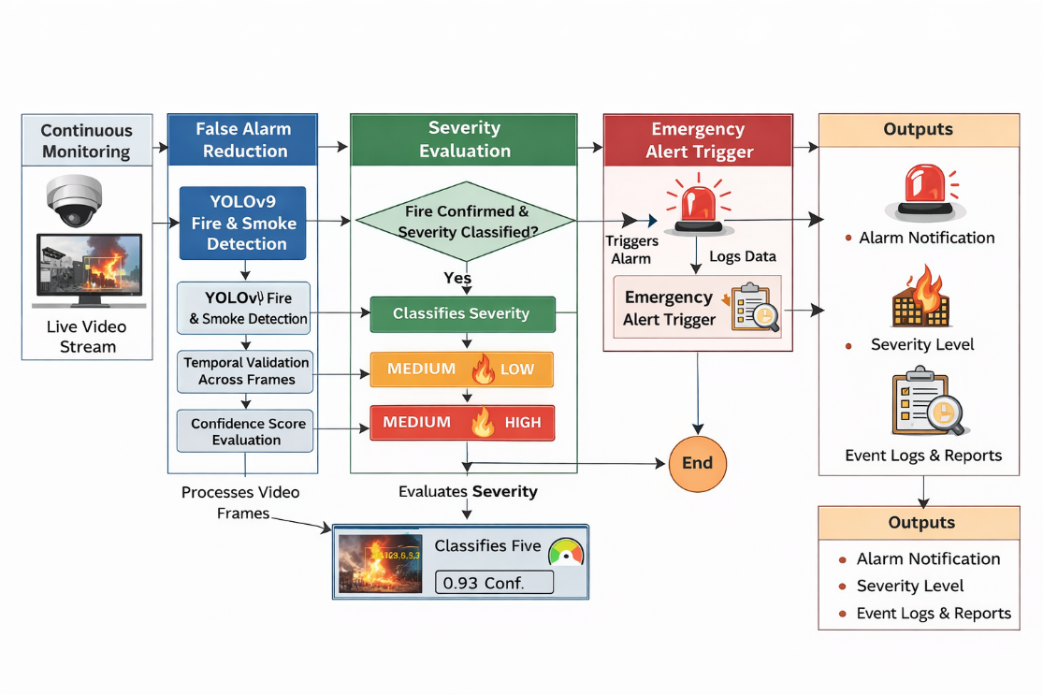
The project flow begins with continuous monitoring of live video streams captured from surveillance cameras installed in the target environment. Each video frame is processed in real time using the improved YOLOv9 model to detect the presence of fire or smoke and generate corresponding confidence scores. To ensure reliable detection and avoid false alarms, the system performs temporal validation by analyzing detections across multiple consecutive frames and confirming only those events that consistently exceed a predefined confidence threshold. Once a fire incident is validated, the system evaluates the confidence and visual intensity of the detected fire to classify its severity into low, medium, or high levels. Based on this classification, the system automatically triggers an emergency alert to enable rapid response and mitigation. Simultaneously, all relevant information such as detection time, confidence score, severity level, and alert status is recorded in structured log files, which can later be used for safety audits, performance analysis, and further enhancement of the fire detection system.

HARDWARE & SOFTWARE REQUIREMENTS
SOFTWARE REQUIREMENS
Operating System : Windows 10
Server Side Script : Streamlit
Programming Language : Python 3.11.4
Libraries : Pandas, Torch, Keras, Sklearn, Numpy, Seaborn
IDE/Workbench : VSCode
HARDWARE REQUIREMENTS
Processor - I3/Intel Processor
RAM - 8GB (min)
Hard Disk - 128 GB
Key Board - Standard Windows Keyboard
Mouse - Two or Three Button Mouse
Monitor - Any
ARCHITECTURE:
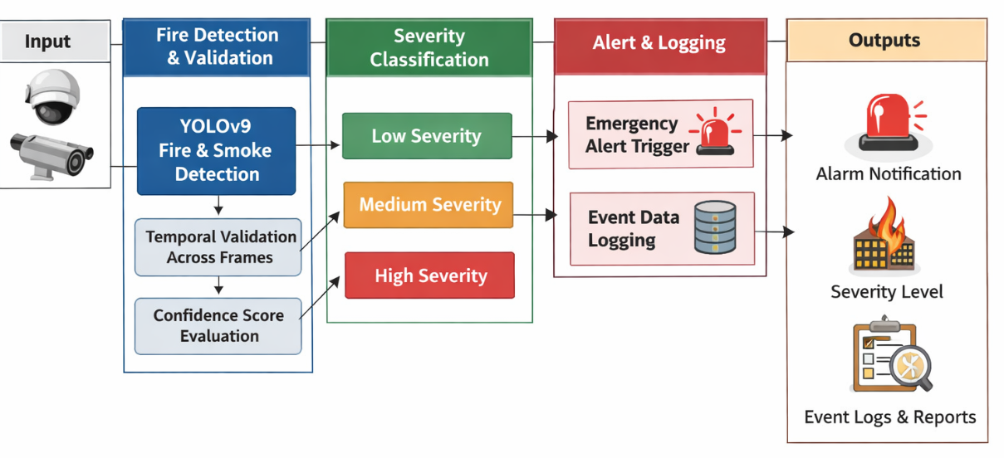
System Architecture
MODULES:
Data Collection and Video Acquisition
The Data Collection and Video Acquisition module is the initial and most critical component of the proposed fire detection system, as the overall performance of the system heavily depends on the quality and continuity of input data. In this module, real-time video data is collected from surveillance cameras such as CCTV cameras, IP cameras, or outdoor monitoring systems installed in the target environment. These cameras continuously capture live video streams covering areas like residential buildings, industrial facilities, warehouses, forests, and public spaces. The video feed is acquired at an optimal frame rate and resolution to ensure a balance between detection accuracy and computational efficiency. Each incoming video stream is decomposed into individual frames, which are then forwarded to the processing pipeline for further analysis. This module is designed to handle variations in illumination, camera motion, weather conditions, and environmental noise, ensuring robust data acquisition under real-world conditions.

Fire and Smoke Detection Using YOLOv9

The Fire and Smoke Detection module is responsible for identifying the presence of fire or smoke within the collected video frames using an improved YOLOv9 deep learning model. In this module, each frame obtained from the data collection stage is processed through the YOLOv9 network, which has been trained on diverse fire and smoke datasets representing various environments and fire scenarios. The model extracts high-level spatial and contextual features using convolutional layers and detects fire or smoke regions by generating bounding boxes along with confidence scores. These confidence scores represent the probability that the detected region corresponds to a real fire or smoke event. YOLOv9 is particularly suitable for this task due to its fast inference speed and high detection accuracy, making it ideal for real-time safety applications. The model is capable of distinguishing fire and smoke from visually similar objects such as fog, dust, sunlight reflections, and vehicle exhaust. By performing detection directly on live video streams, this module enables early identification of hazardous events. The output of this module consists of detection labels, bounding box coordinates, and confidence values, which are passed to the validation module for further verification. This module acts as the core intelligence of the system, enabling automated and efficient fire monitoring without human intervention.

Temporal Validation and False Alarm Reduction
The Temporal Validation and False Alarm Reduction module plays a crucial role in improving the reliability and robustness of the proposed fire detection system. Vision-based fire detection systems often suffer from false alarms caused by transient visual disturbances such as dust particles, camera noise, shadows, or sudden lighting changes. To overcome this limitation, this module performs temporal analysis by validating detected fire or smoke events across multiple consecutive video frames. When the YOLOv9 model detects a fire or smoke region, the detection is not immediately confirmed. Instead, the system tracks the detection results over a predefined number of continuous frames and checks whether the confidence score remains above a specified threshold. Only detections that persist consistently across frames are confirmed as real fire incidents. This temporal consistency check effectively filters out short-lived or accidental detections that could otherwise trigger unnecessary alarms. The module maintains a sliding window of detection results and applies logical rules to confirm event stability. By reducing false alarms, this module enhances system trustworthiness and prevents alert fatigue. It ensures that only genuine fire incidents proceed to severity classification and alert generation, making the system suitable for deployment in real-world environments where reliability is essential.

Fire Severity Assessment and Classification
The Fire Severity Assessment and Classification module evaluates the intensity and seriousness of confirmed fire incidents to enable prioritized emergency response. After a fire or smoke event is validated, this module analyzes detection parameters such as confidence score, size of the detected fire region, and temporal persistence to classify the incident into one of three severity levels: Low, Medium, or High. Low-severity fires typically represent early-stage flames or minor smoke emissions, while medium-severity fires indicate growing flames that require immediate attention. High-severity classification corresponds to intense or widespread fires that pose a significant threat to life, property, and infrastructure. This severity-based categorization helps emergency responders and safety systems take appropriate action based on the level of risk. The classification results can also be integrated with intelligent decision-making systems for resource allocation and evacuation planning. By automating severity assessment, the system eliminates the need for manual evaluation and ensures faster response times. This module adds intelligence and practicality to the fire detection system, transforming raw detection outputs into meaningful, actionable information for effective fire management.

Emergency Alert Generation and Event Logging
The Emergency Alert Generation and Event Logging module is the final stage of the proposed system and focuses on response and data management. Once a fire incident is confirmed and its severity is classified, this module automatically triggers an emergency alert without human intervention. The alert may include visual alarms, audible sirens, or digital notifications to responsible authorities, depending on system configuration. This immediate alert mechanism ensures rapid response, helping to minimize damage and prevent fire escalation. Simultaneously, the module records all relevant event details such as detection time, camera ID, confidence score, severity level, and alert status in structured log files or databases. These logs serve as valuable resources for post-incident analysis, safety audits, system evaluation, and future improvements. Event logging also supports compliance with safety regulations and enables performance monitoring of the detection system over time. By combining automated alerting with comprehensive logging, this module ensures both real-time safety response and long-term system reliability, completing the end-to-end fire detection and management workflow.

